Spring Framework

Introduction
Nowadays, we use a number of frameworks to build our application. For example
- Spring
- Spring Boot
- Hibernate
- Spring Security
- Spring Data
- Spring Cloud

The two important frameworks that needs to be learnt to build the great applications are:
- Spring Framework
It provides the most important features needed for the easily maintainable - Dependency Injection & Autowiring

- Spring Boot: It makes the Spring framework really easy.

The evolutions of the frameworks made the applications handling very easy for example,
If 1000 lines were getting written before Spring framework
With Spring Framework it reduces to 700 & with Spring Boot to 400 lines. It reduces productivity.

There are Spring specific terminologies:
- Tight Coupling
- Loose Coupling
- Dependency Injection
- IOC Container
- Application Context
- Spring Beans
- Auto Wiring
- Component Scan

Getting Started with Spring Framework
A wide variety of applications can be built using Spring Framework like:
- Web Application
- Rest APIs
- Micro Services
- Full Stack Applications

Irrespective of the application we can build, Spring Framework Provides all the required Core Features & once we understand Spring Framework, Spring Boot can be learnt easily. Also , it helps in debugging problems quickly.

Understanding Core Features

Lets understand core features of Spring Framework by building a Loosely Coupled ‘Hello World Gaming App’ with Modern Spring approach.

Terminologies (Tight Coupling, Loose Coupling, Dependency Injection, IOC Container, Application Context, Spring Beans, Auto Wiring, Component Scan)

Approach: Design Game Runner class to run a number of games like - Mario, SuperContra, Pacman etc in an Iterative approach.

- Iteration - 1: In 1st iteration, we shall be building a Tightly coupled Java App.
  - Create a GameRunner class
  - Use GameRunner class to run the Game classes
- Iteration - 2: Loose Coupling - using Interfaces
  - Create GameRunner class
  - Create GamingConsole Interface
    - Create the Game classes by implementing the GamingConsole Interface
- Iteration - 3: We will see the first level of Loose Coupling using Spring
  - Create a number of Spring Beans
  - Spring Framework will manage the created objects & wiring
- Iteration - 4: We will see the Second level of Loose Coupling using Spring
  - Bring some Spring Annotations
  - By the end of this iteration, Spring Framework will be responsible for creating, managing & Auto-wiring objects.

Create Spring Framework Project using Maven & Java

Let's create our first Spring Project

- Go to website Spring Initializr: https://start.spring.io/

- Populate the Important & required details required for the project:

Project | Maven Project  (Maven - Dependency Management Tool/Build Tool)  It downloads Spring & makes it available for our project.
Language | Java
Spring Boot Version | 3.4.4 (or select the latest released version)  (Never use SNAPSHOT versions, these are currently in development phase by the Spring Boot team)
Project Metadata
Group | same as Package id (Eg: learn.springframework)
Artifact & Name | Project name (Eg: my-project-a-spring-framework)
Description | Learn Spring Framework
Package Name | groupId.artifactId  Eg: “learn.springframework.my-project-a-spring-framework”
Packaging | Jar
Java Version | 21

- After providing all the details, click on Generate button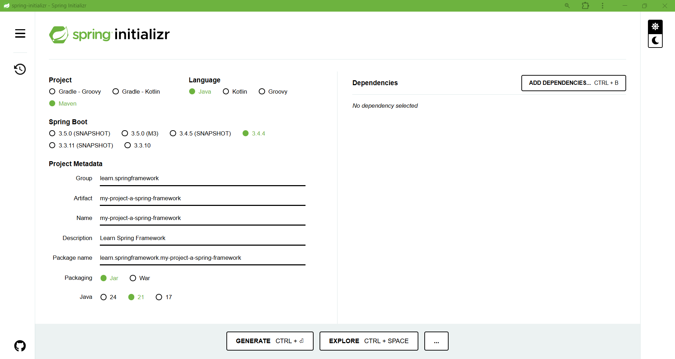

- A zip file will be downloaded into the pc, unzip the project file in to the Eclipse Workspace (or any other location as per user’s choice)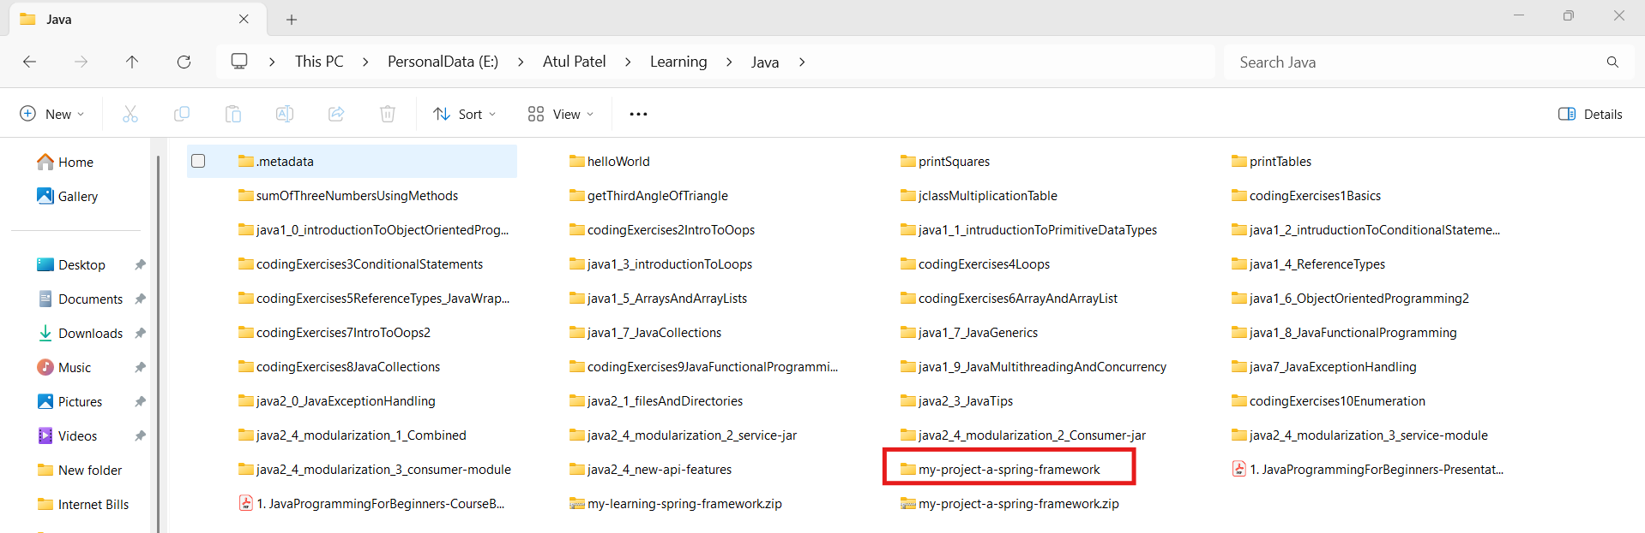
- Now Import the project into the Eclipse: Goto Files → Import → Select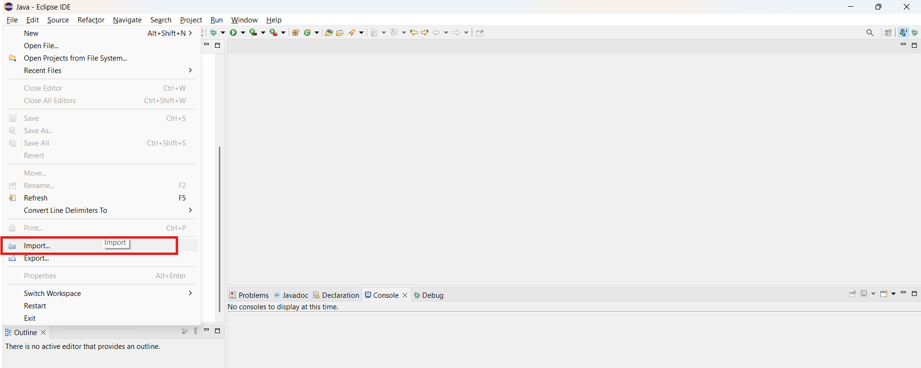

- An Import window will appear, Search for Maven, select “Existing Maven Projects” & click Next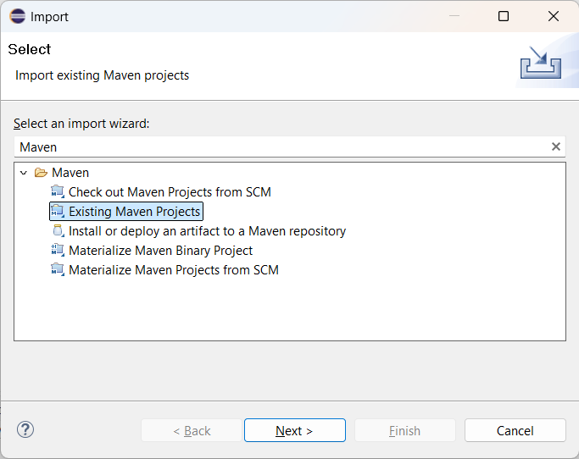
- Root Directory Selection window will appear. Now click “Finish”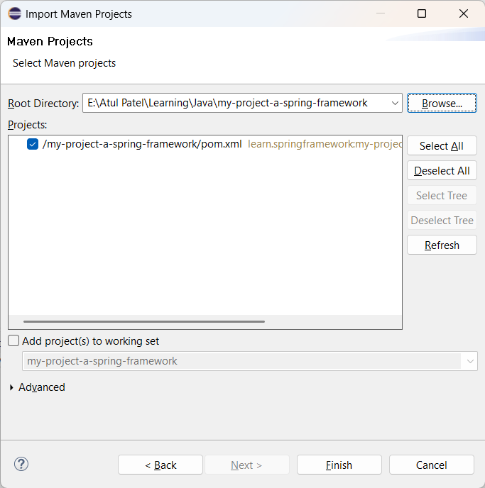
- It will take some time & once finished, we will be able to see the project the the explorer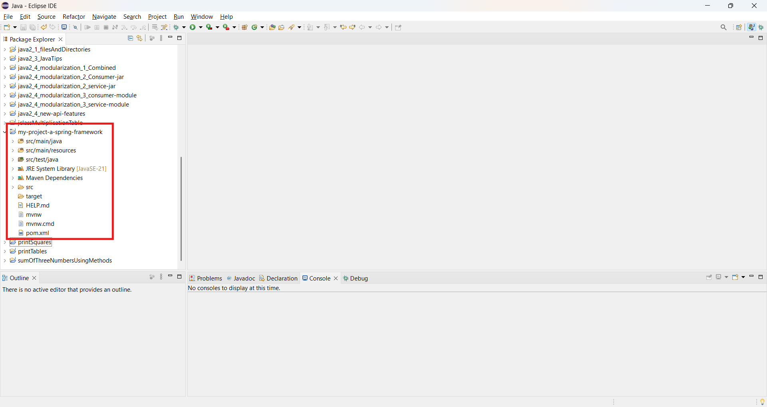

src/main/java - will have all the source file
src/main/resources - stores all the configuration files
src/test/java - test code will be written here.

Now we have created our first Spring Project using Spring Initializer.
Earlier it used to take 1-2 hours to setup a new Spring /Spring Boot Project

Iteration - 1: Create GameRunner & Games Classes

Goto the project → Create “AppGamingBasic”class under Package “learn.springframework.my_project_a_spring_framework” → Click finish to create class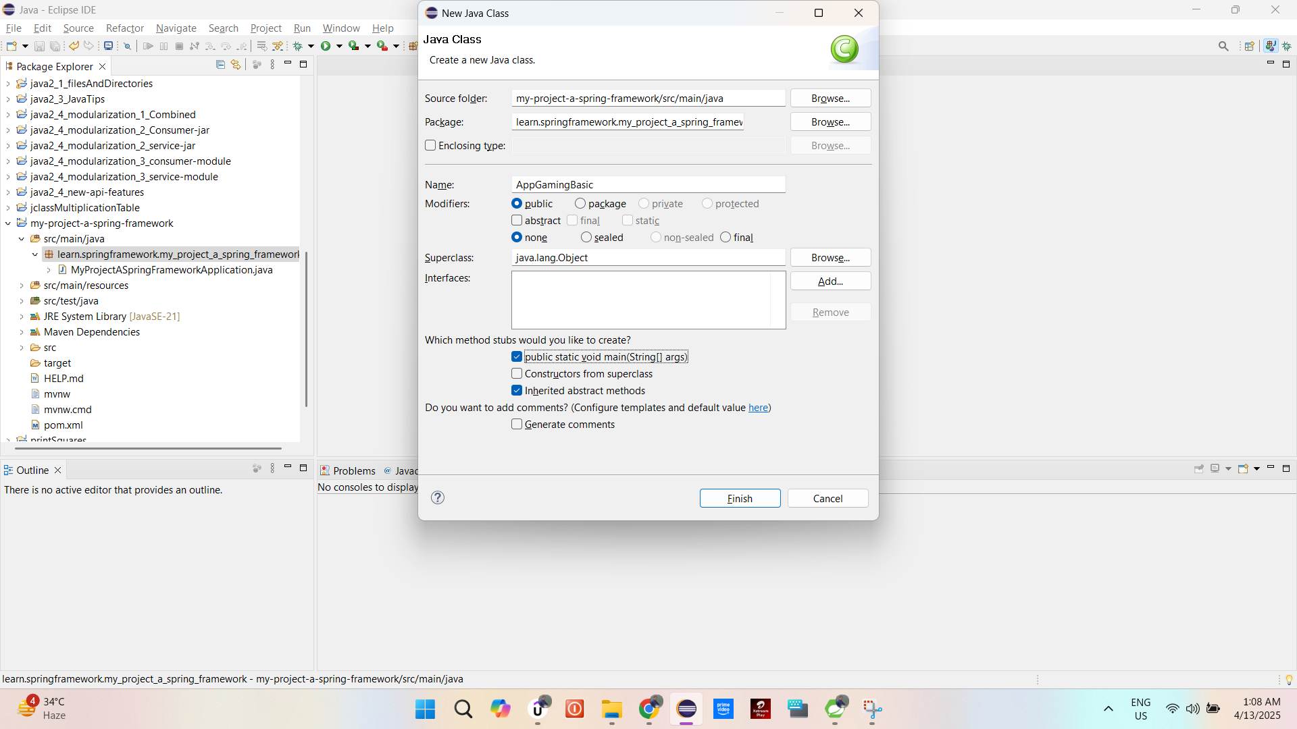

Create an instance of GameRunner & MarioGame Classes in it.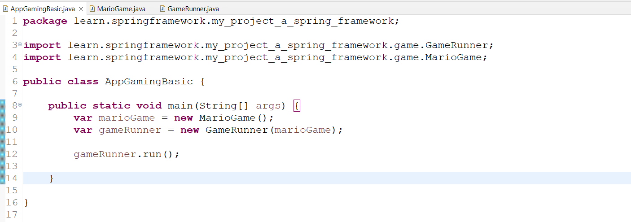

GameRunner & MarioGame classes will be created in the package:
→ learn.springframework.my_project_a_spring_framework.game;
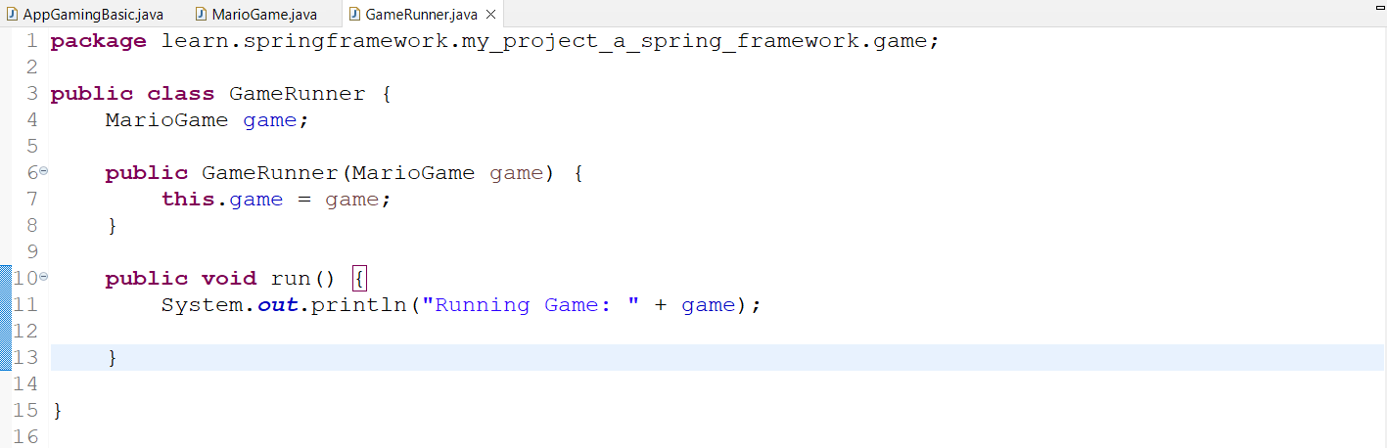
The required constructor & run() method will be created to to run the game

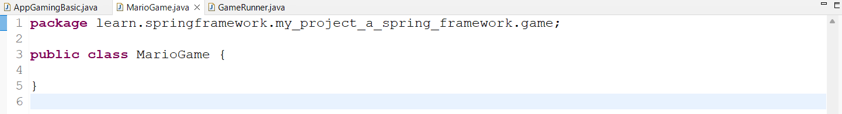

Now run the AppGamingBasic, it should print the output in the console.
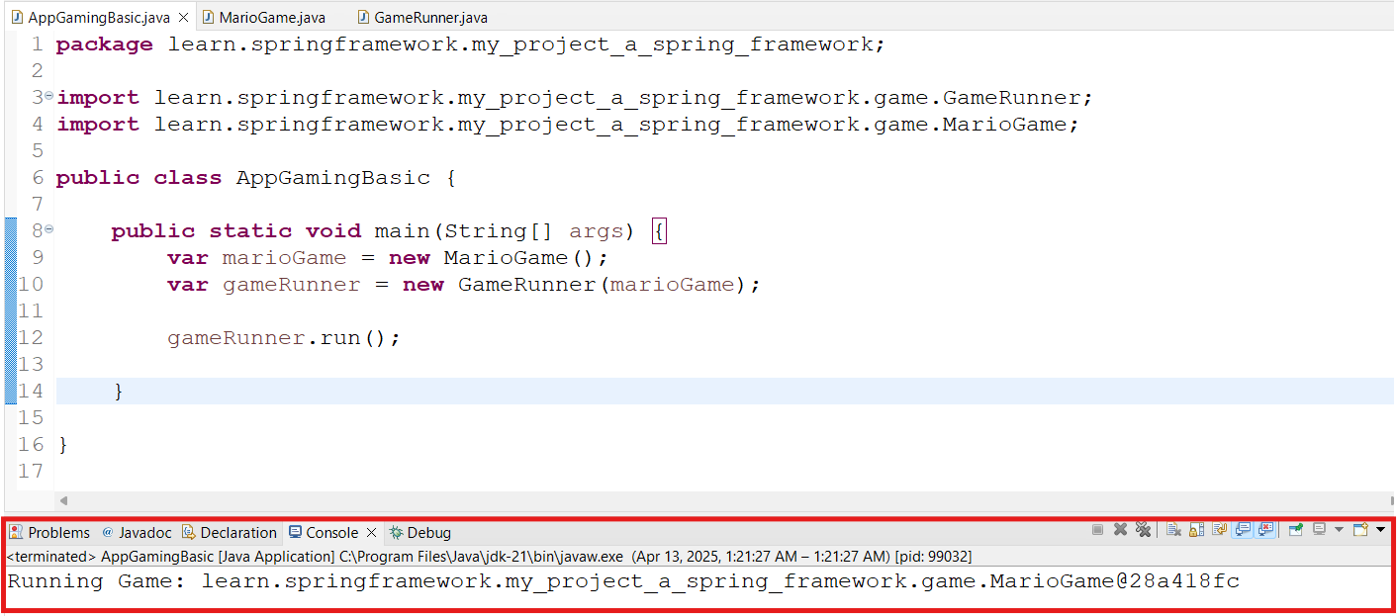

Build Buttons Functionality

A gaming console also has some buttons like - Left, Right, Up & Down. So let’s implement the functionality for these buttons in the MarioGame Class.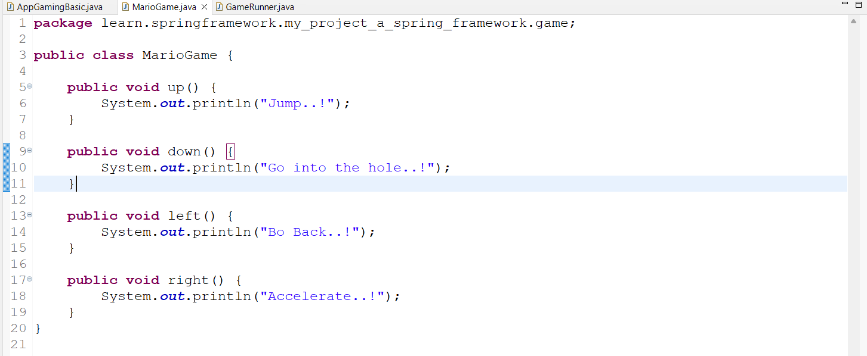

These actions will be called in the GameRunner class.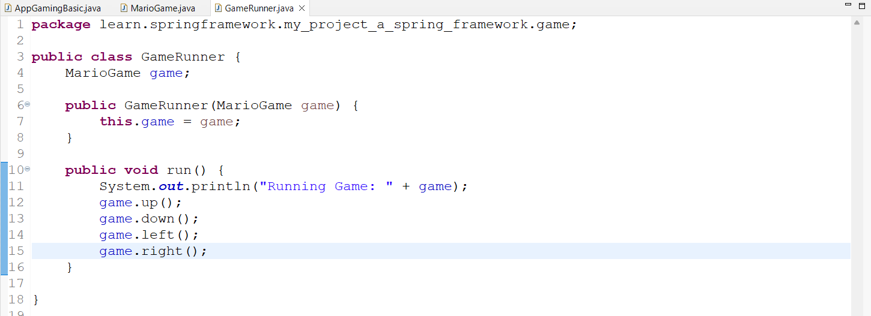

Output:
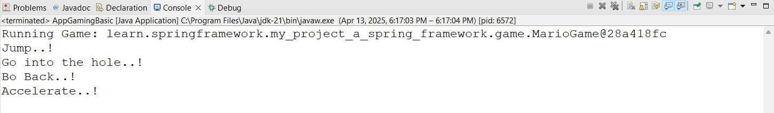

Here, we have created only one Game class- MarioGame class & we are passing its instance as a constructor & the Runner class also has a hardcode for the MarioGame.
Therefore, if we create another game, say - SuperContraGame class, we shall be required to update the AppGamingBasicJava class & GameRunner class.
That’s is why this application is referred as “Tightly Coupled”

Type Coupling - Tightly Coupled

Coupling is an estimation of how much effort will be required to change the application/process.
For example: A car engine is Tightly coupled with the Car & it takes lots of time to change it but a Wheel is Loosely Coupled, so it can be easily changed.

Similarly this is also a Tightly Coupled Logic which is tied to a specific game & it will take time to change the game to make it compatible to other games.

AppGamingBasic class updated for SuperContraGame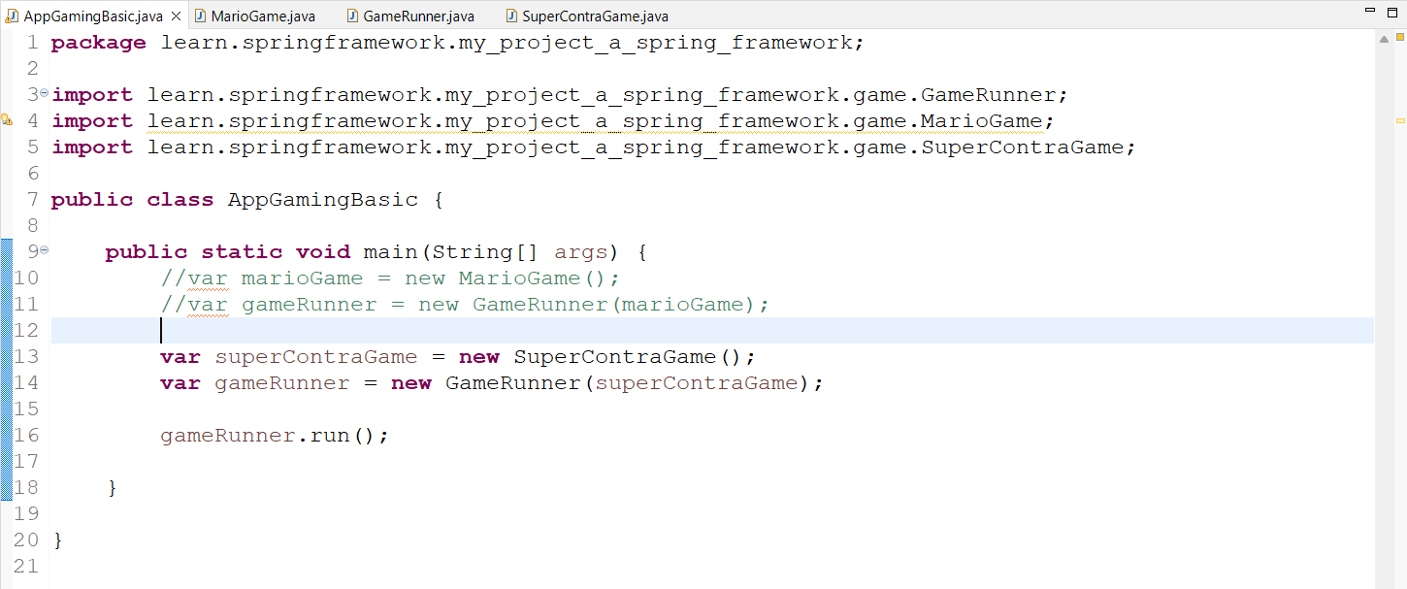

SuperContraGame class is created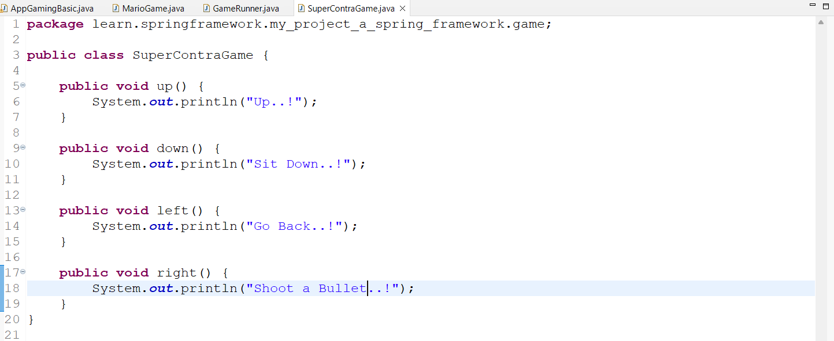

GameRunner class updated for SuperContraGame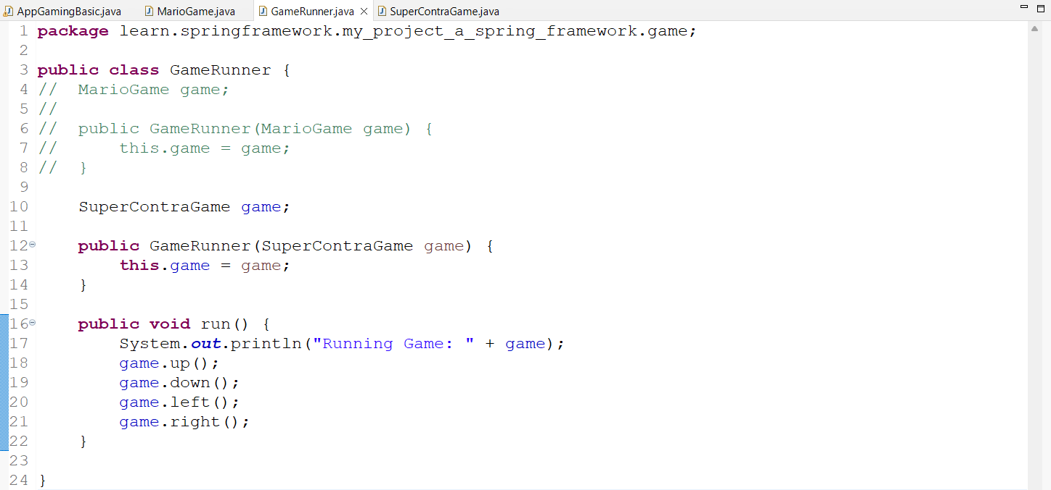

Output: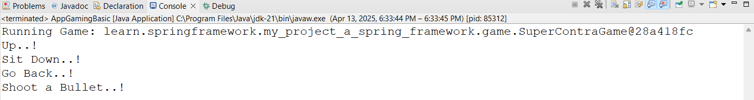

Type Coupling - Loosely Coupled app using Java Interface
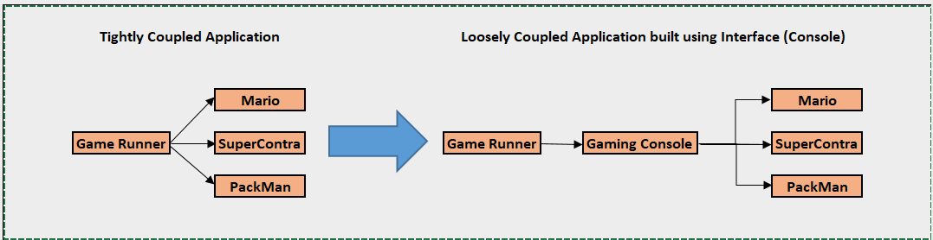
Lets create a loosely coupled application, so that we can select the game which we wish to play without changing the GameRunner class.

Steps:
- Create an Interface - GamingConsole which will have all the methods or actions which will be implemented by all the Game classes like MarioGame, SuperContraGame & PackmanGame.
- GameRunner class will now not be using concrete classes like MarioGame or SuperContraGame instead, GamingConsole will be used to switch b/w the games.
- Also create a PackmanGame class by Implementing GamingConsole interface.

GamingConsole Interface:

package learn.springframework.my_project_a_spring_framework.gameUsingInterface;
public interface GamingConsole {
public default void up() {
}
public default void down() {
}
public default void left() {
}
public default void right() {
}
}

MarioGame:
package learn.springframework.my_project_a_spring_framework.gameUsingInterface;
public class MarioGame implements GamingConsole {
public void up() {
System.out.println("Jump..!");
}
public void down() {
System.out.println("Go into the hole..!");
}
public void left() {
System.out.println("Go Back..!");
}
public void right() {
System.out.println("Accelerate..!");
}
}

SuperContraGame:
package learn.springframework.my_project_a_spring_framework.gameUsingInterface;
public class SuperContraGame implements GamingConsole{
public void up() {
System.out.println("Up..!");
}
public void down() {
System.out.println("Sit Down..!");
}
public void left() {
System.out.println("Go Back..!");
}
public void right() {
System.out.println("Shoot a Bullet..!");
}
}

PackmanGame:
package learn.springframework.my_project_a_spring_framework.gameUsingInterface;
public class PackmanGame implements GamingConsole {
public void up() {
System.out.println("Up");
}
public void down() {
System.out.println("Down");
}
public void left() {
System.out.println("Left");
}
public void right() {
System.out.println("Right");
}
}

GameRunner:
package learn.springframework.my_project_a_spring_framework.gameUsingInterface;
public class GameRunner {
GamingConsole game;
public GameRunner(GamingConsole game) {
this.game = game;
}
public void run() {
System.out.println("Running Game: " + game);
game.up();
game.down();
game.left();
game.right();
}
}

AppGamingBasicB:
package learn.springframework.my_project_a_spring_framework;
import java.util.Scanner;
import learn.springframework.my_project_a_spring_framework.gameUsingInterface.GameRunner;
import learn.springframework.my_project_a_spring_framework.gameUsingInterface.SuperContraGame;
import learn.springframework.my_project_a_spring_framework.gameUsingInterface.MarioGame;
import learn.springframework.my_project_a_spring_framework.gameUsingInterface.PackmanGame;
public class AppGamingBasicB {
public static void main(String[] args) {
var marioGame = new MarioGame();
var superContraGame = new SuperContraGame();
var packmanGame = new PackmanGame();
Scanner scanner = new Scanner(System.in);
System.out.println("<<<<---Gaming Menu--->>>>");
System.out.println("1. Mario Game");
System.out.println("2. SuperContra Game");
System.out.println("3. Packman Game");
System.out.println("Select Game & hit enter to play!");
System.out.print("Option==>");
int userOption = scanner.nextInt();
switch (userOption) {
case 1:
var gameRunnerA = new GameRunner(marioGame);
gameRunnerA.run();
break;
case 2:
var gameRunnerB = new GameRunner(superContraGame);
gameRunnerB.run();
break;
case 3:
var gameRunnerC = new GameRunner(packmanGame);
gameRunnerC.run();
break;
default:
System.out.println("Invalid Selection");
}

scanner.close();
}
}

Here, when the game will be triggered , users will get a menu of the available games & users can select their wish.

When selected, the respective game will be triggered.

Output: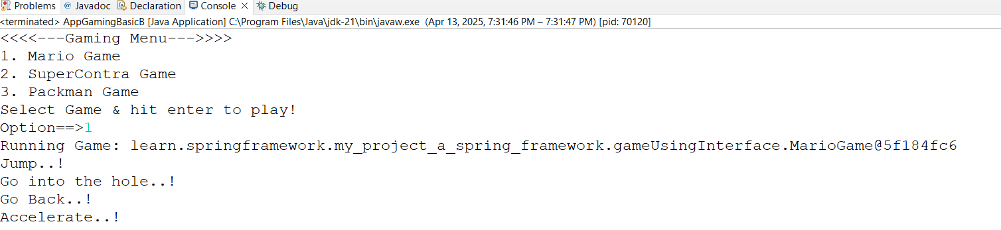

Create Loosely Coupled Java App using Spring Framework

In the above example we have seen that, a developer is responsible to manage the objects for the different games & passing as an argument to the GameRunner class:

- Object Creation: var marioGame = new MarioGame();
- Object Creation + Wiring of Dependencies:
var game = new GameRunner(marioGame);
Here, Game is a Dependency as it can be any game. Once the game object is created it is injected/wired to the GameRunner class.
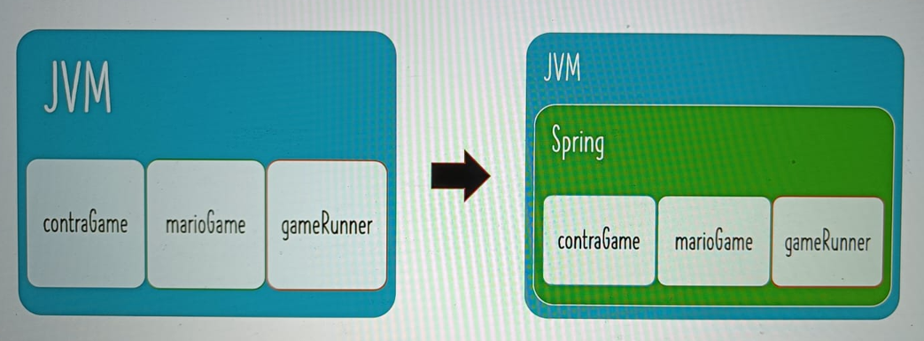
Now, we will see how we can use Spring Framework in managing these things.

But Before starting with GamingRunner, let’s see a simple example where we can manage simple objects like name, age, person, person2 & address.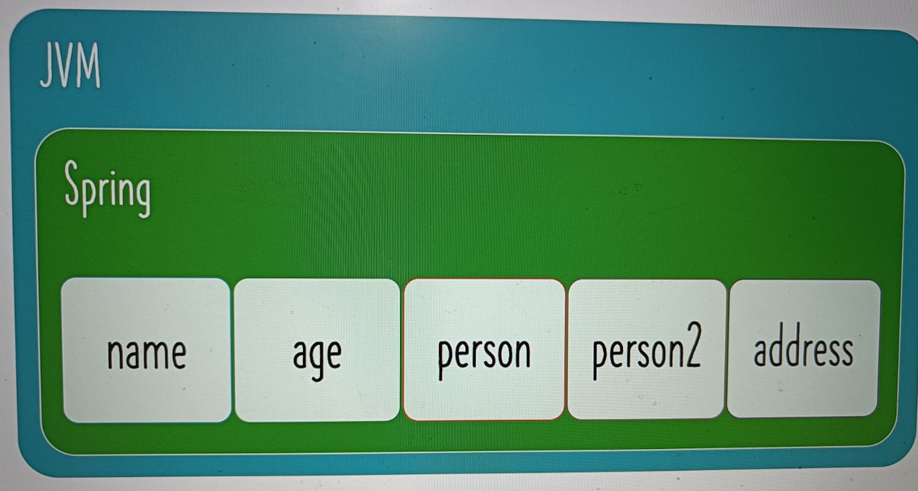

Create a class App03HelloWorldSpring class with the main method.
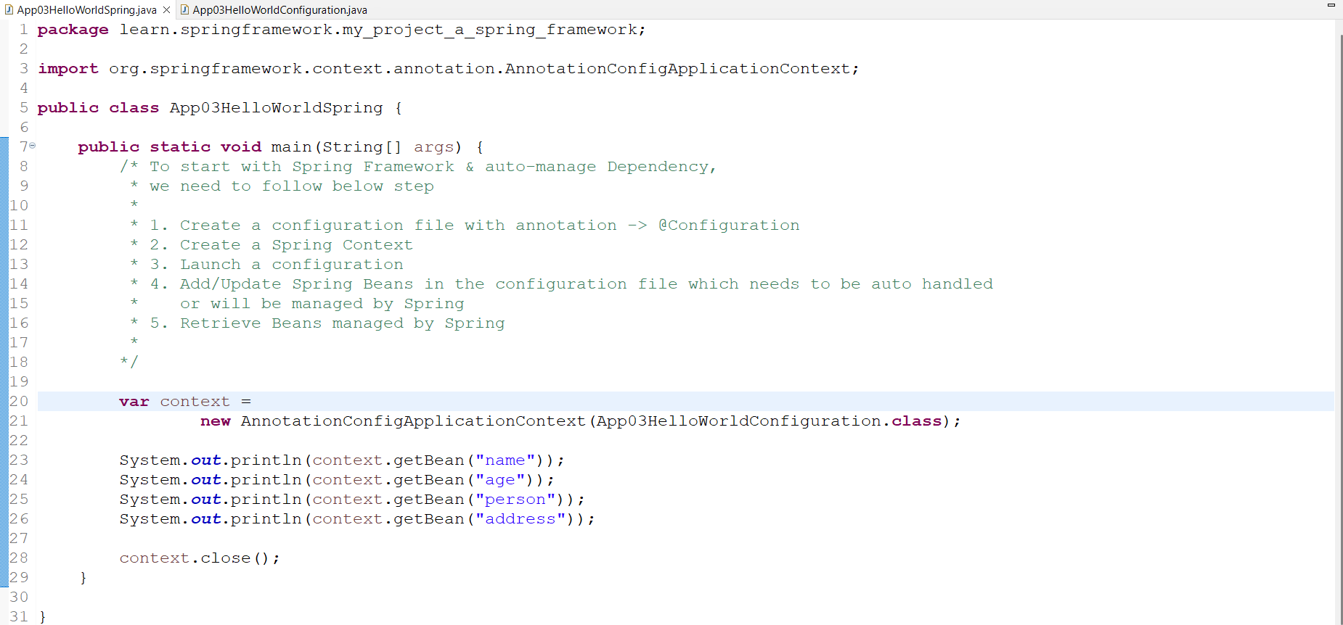

Note: We can retrieve the Bean either By using name of the Bean or Type of the Bean.

Create Configuration class - App03HelloWorldConfiguration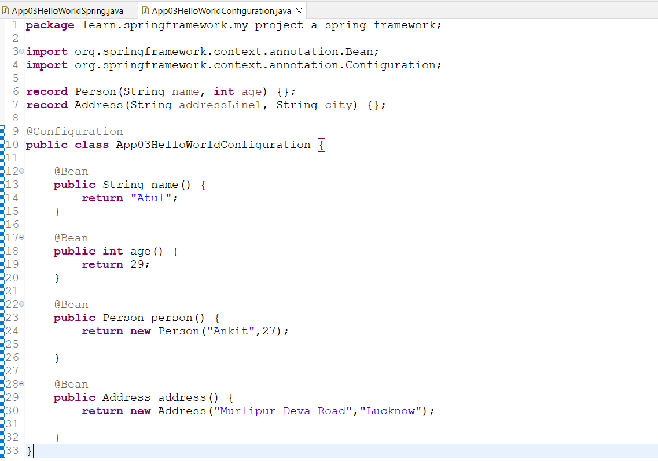

Note: Configurations class is defined using the Annotation : @Configuration
& Beans are defined using Annotation that needs to be managed by Spring : @Bean

Auto-Wiring
- Implement Auto-Wiring in Spring Framework Java Configuration

The Default Bean name for the name, age, person & address are same as “name”, “age”, “person” & “address” respectively

But if we wish to customise the Bean name, we can do it passing as an arguments to the Bean - Annotation: @Bean(“newBeanName”)

- Reuse Existing Bean for Auto-Writing
Let’s create a new Bean(person2) using existing Beans(name & age)

There are 2 ways to achieve it:
- By using Method Call (Auto-Wiring using Method Calls happens)
Example: Creating a person2MethodCall Bean using existing Beans - name, age & address

@Bean
public Person2 person2MethodCall() {
return new Person2(name(),age(),address());

}

- By using Method Parameters (Auto-Wiring using Method Calls happens)
@Bean
public Person2 person3MethodParameters(String name,
int age, Address address) {
return new Person2(name,age,address);

}

Lets see questions coming in our mind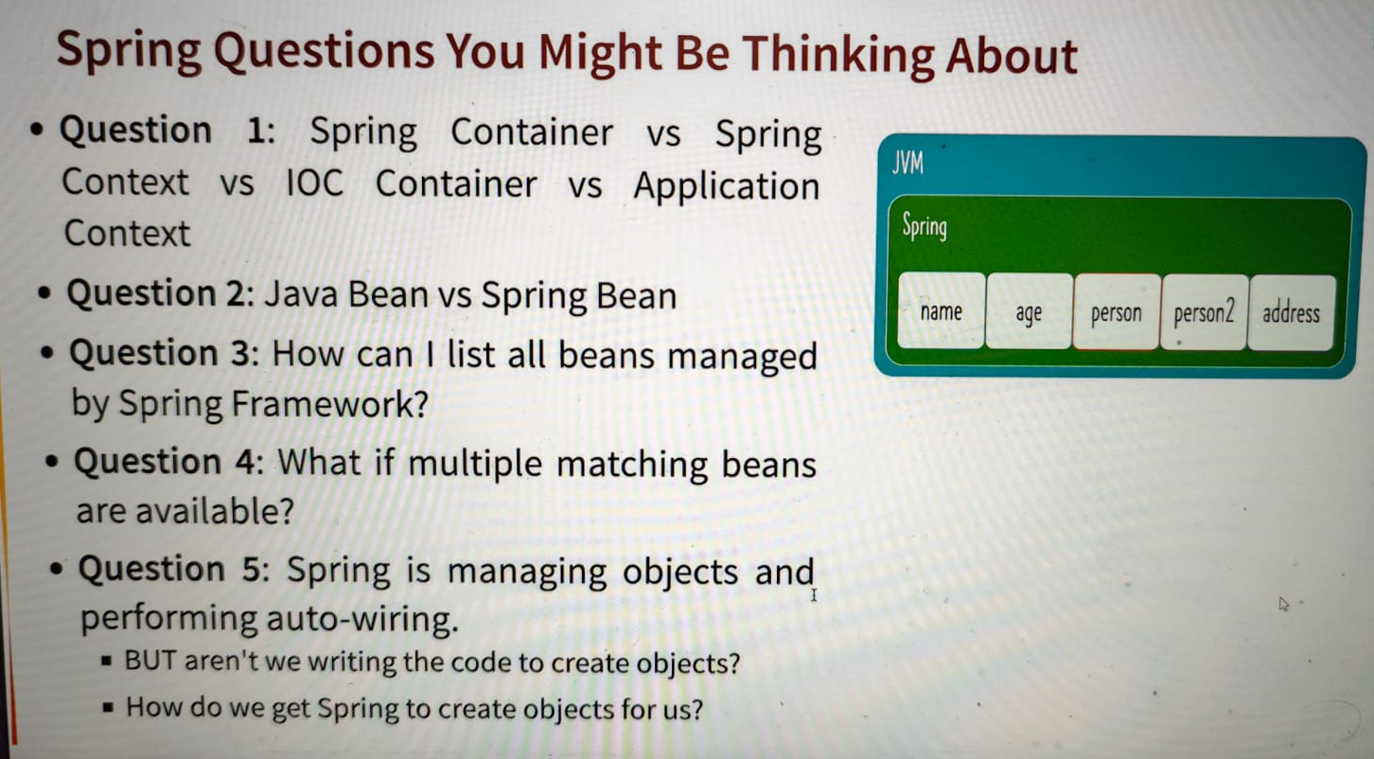

Question - 1: What is Spring Container
A Spring Container is the one responsible for managing Spring Beans & their lifecycle.
There area lot of terminologies are being used for Spring Container like -
- Spring Context
- IOC(Inversion of Control) Container

It takes classes & Configured files as input & creates IOC containers ready for the System.

There are 2 types of very popular IOC containers:
- Bean Factory - It is a basic Spring Container
- Application Context - It is an Advanced Spring Container with Enterprise-Specific Features. It offers below features
  - Easy to use in Web Applications, Web Services, REST APIs & microservices
  - Easy Internationalization
  - Easy integration with Spring AOP
That's why this is mostly used in building enterprise applications.

Even in our application created above, used the APplication context

Question - 2: What is the difference b/w Java Bean, POJO & Spring Bean?

POJO - Plain Old Java Object: Any Java object is a POJO.
Any Bean which we have created as part of learning, is a POJO.

Java Bean: This was most popular earlier for building Enterprise Applications. Due to Enterprise Java Bean(EJB), there are some restrictions for creating Java Bean:

- It must have a public no-argument constructor
- It should have getters & setters
- It must implement Serializable Interface

Nowadays, it is not so popular & is not being used.

Spring Bean: Any Bean which is created & managed by Spring is called Spring Bean.
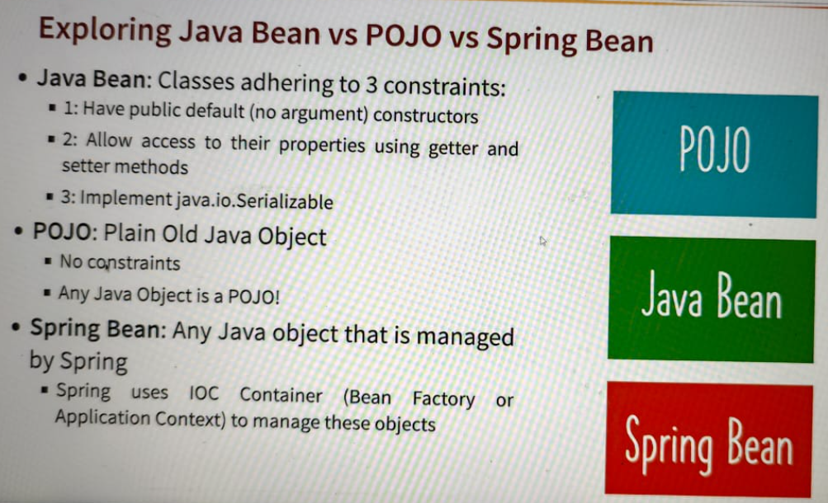
Question - 3: How to list all the Beans managed by Spring Framework?

We can list all the Beans managed by Spring Framework using Spring Context followed by getBeanDefinitionNames().

This will return a String Array of all the Beans which we can loop or stream to get the Bean Names.

Also .getBeanDefinitionNames() returns the count of Beans.
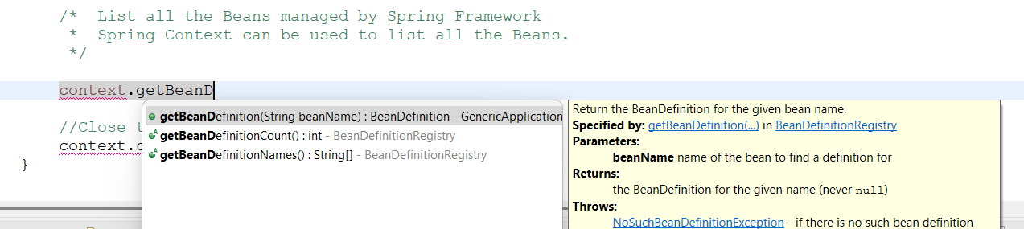

/* List all the Beans managed by Spring Framework
* Spring Context can be used to list all the Beans.
*/

System.out.println("\nListing all the Beans managed by Spring Framework");
Arrays.stream(context.getBeanDefinitionNames())
.forEach(System.out::println);

System.out.println("Count of Beans==>"
+ context.getBeanDefinitionCount());

Question - 4: How to manage if matching Beans are present?

- Using @Primary Annotation: We can make one of the Bean as Primary to resolve the issue.
- Using @Qualifier(“newBeanName”) Annotation: Use this for Auto-Wiring instead of Bean name.

Gaming Application - Solution
Now we are good to proceed to create a Configuration file for our Gaming App where we will be configuring Beans for.

- GamingConsole to select the game or to return the Game Object
- GameRunner to run the Game.

Configuration File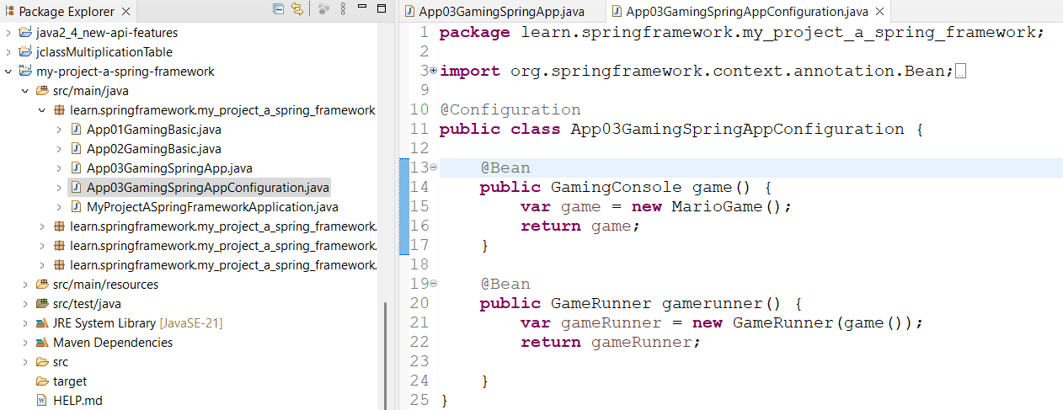

Application Runner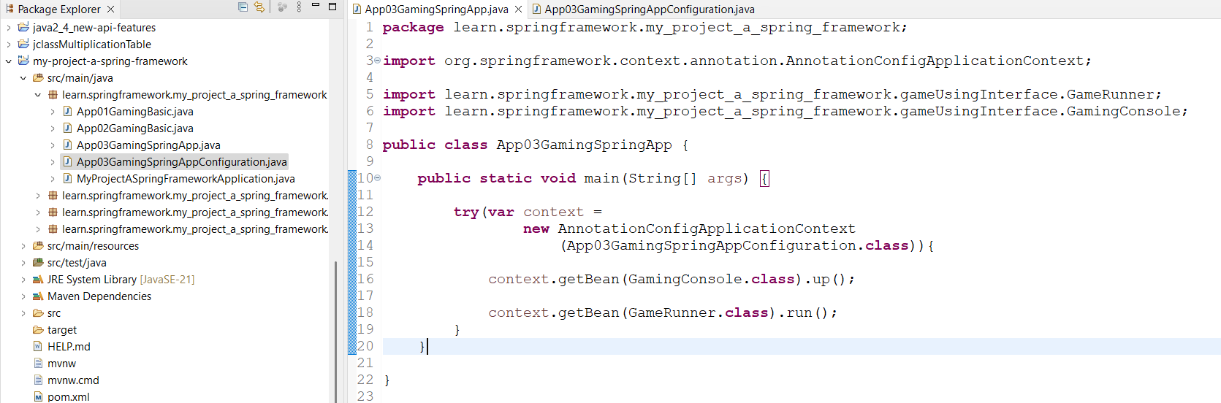

Output:
